OOADJ project

Team 12

Saurabh Yadav – PES2UG19CS371

Sapna Singh – PES2UG19CS366

Shreyas G – PES2UG19CS387

Satwik Bansal – PES2UG19CS470

State diagrams:

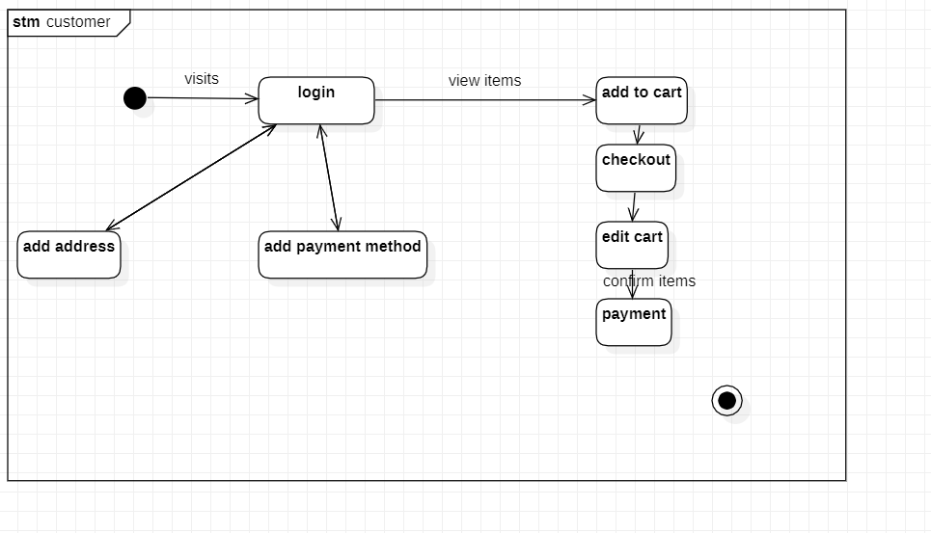

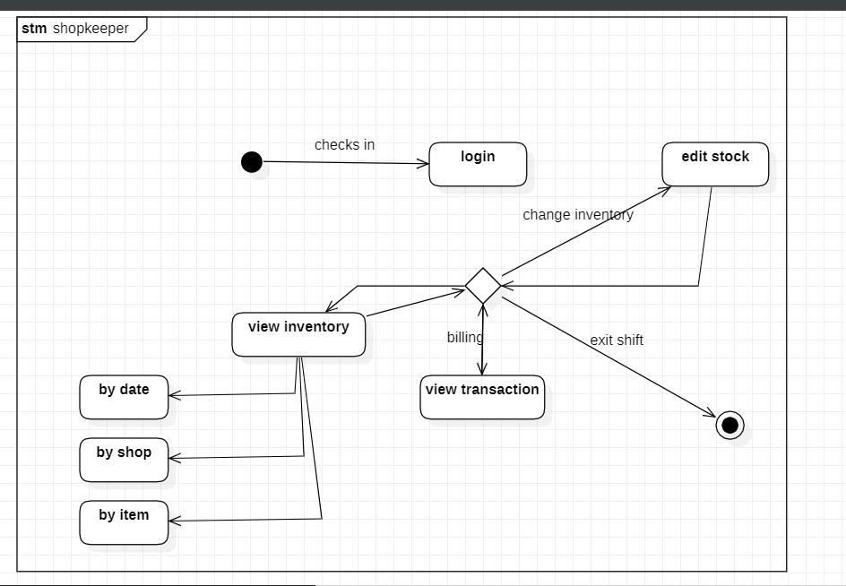

Activity diagram:

